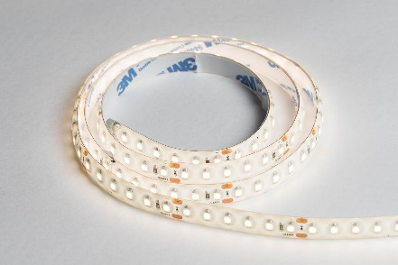

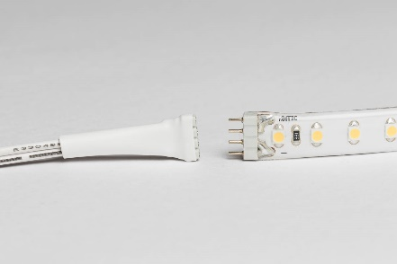

Specifications:
Voltage: 24V
LED quantity per Meter: 120
Wattage per Meter: 9.6 W
Beam Angle: 120°
Kelvin: Natural White 4000K/ Cool White 6000K
Lumens: 86 lm
Finish: White
Length: 1000mm & 2000mm
Life span: 50,000 hours
CRI/RA: 90
Lm/meter: 768

Product Code:
IL200NW/CW (1 meter)
IL202NW/CW (2 meters)
Accessories:
IL102: Intuition 24V 30W LED Driver with 12 Port Block
IL103: Intuition 24V 60W LED Driver with 12 Port Block
IL900: 2.5M CABLE extension for driver
IL901: LED flexible strip mini cut connector
IL902: LED flexible strip corner cut connector (50mm)
Dimensions: (W 10mm x D 3mm)

Key Selling Points:
- High number of diodes per flexible strip means minimal dark spots, ideal for use on a plinth in a room with a glossy finish near the light.
- Self-adhesive 3M tape backing allows for quick installation on any flat surface.
- Male and female ends on the strips allow for your desired length to be easily achieved.
- The strip can be cut to length, scissor marks show where to make the cut. Every 50mm.
- You can re-use the strip ONCE when cut using one of the mini cut connectors described above. (IL901)
- Use joined strips around corners of your cabinets, or your bed using the mini corner connector (IL902)
- Use this strip for under cabinets in your kitchen, along the lower cabinet perimeter of your kitchen, on the underside of the bed base in your bedroom, above wardrobes or other cabinets to up-light the room. Can also be used well with an aluminium profile
- Easy installation with your flexible strip, connector lead to your driver and your driver. Use one run of strips per driver.
- You can run up to 6m of strips per 60W driver
- Over 90% less energy used – save money on your electric bills.

