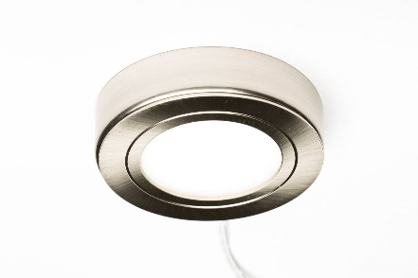

Specifications:
Voltage: 24V
Wattage: 1.85 W
Beam Angle: 100°
Kelvin: Natural White 4000K/ Cool White 6000K
Lumens: 100 lm
Finish: Stainless Steel
Cable Length: 1.5 meters
Life span: 30,000 hours
Cri/Ra: 80

Product Code:
IL300NW/CW

Accessories:
IL101: Intuition 24V 15W LED Driver with 6 Port Block
IL102: Intuition 24V 30W LED Driver with 12 Port Block
IL103: Intuition 24V 60W LED Driver with 12 Port Block
IL900: 2.5M CABLE extension for driver

Dimensions: Circumference: 67mm
Cut out size 48mm
Surface housing diameter: 67mm
Recessed light diameter: 65mm
Thickness of recessed light: 11mm

Wiring Diagram:

Key Selling Points:
- Product supplied with outer housing to enable surface lighting mounted
- LEDs are diffused by a frosted cover, for a more solid and pleasing lighting effect, whilst maintaining high light output. No visible dots.
- Stainless Steel fitting available in Natural White or Cool White.
- Direct replacement for Halogen under cabinet recess/surface light.
- Long lamp life
- Over 90% less energy used than Halogen – save money on your electric bills.

